Introduction to Software Engineering
Term PROJECT
Enter your company name here

Submitted To:

Submitted By:

Objective of Project:
As the technology is advancing day by day our Hotel needs to be advanced as well , so that our customers will be facilitate with the latest technology being used by many hotels worldwide. Our customers are really special for us and we want our customers to save their precious time by providing them an automated system through which they can easily reserve their rooms by themselves without waiting for the clerk to check and tell that which rooms are available. The main goal of this Hotel (Peckham Lodge) is to create a system to manage the reservation system through which our guest would easily come to our hotel and make the reservations of Room by his own and there would be no use of a clerk. If guests are not willing to use the automated system then they can come to counter and let the receptionist to reserve the room for them.
Introduction to the organization:
Peckham Lodge is a Four Star Hotel. It is one of Great Britain’s most charming and hospitable budget hotels. Located in London, this Victorian lodging facility is just a short distance from renowned attractions such as the Tower Bridge, Peckham Square, and the South London Gallery. It consists of more than 200 rooms.Each guestroom at Peckham Lodge offers a tranquil and relaxing environment for travellers. Guests have the option of reserving a room with a private or shared bathroom. Single classic rooms offer affordability and comfort. Twin, double and triple en-suite rooms are also available. Hotel rooms contain safety deposit boxes, televisions and coffee makers. Telephones, hairdryers and complimentary toiletries are also included. Climate control features are easy to adjust for ideal room temperatures. An electronic key entry system offers additional security. Daily housekeeping ensures that all guestrooms are cleaned to the highest standards. Irons and ironing boards are available upon request.
Peckham Lodge also features common areas for guests to enjoy. A 24-hour business center gives professional travellers the opportunity to take care of business matters during their stay. A 24-hour reception area is always open to welcome guests. Hotel patrons can take a stroll through the property’s enchanting garden. Guests also have access to complimentary wireless Internet service in certain public areas. This hotel offers a free continental breakfast, featuring traditional English foods.
Peckham Lodge is only 20 minutes from Central London and is easy to access by bus or train. This hotel is a short walking distance from Peckham Rye, Denmark Hill and other major railway stations. Nearby tube stations include New Cross Gate, Kensington and Oval. Transportation to and from Heathrow and Gatwick airports can also be easily arranged. Guests who choose to drive to Peckham Lodge have the option of parking in the free and secure parking lot during their stay.

Brief details of the existing system:
In the existing system, When a guest comes in , he asks the receptionist to tell that if the rooms are available or not. And what is the daily rate of Specific room. Then Receptionist checks the available rooms and if rooms are available then he asks for the reservation that if the guest want to make reservation.
If reservation has to be done then receptionist enter the details of the guest like Phone number, Name, address and Credit-Card number if the mode of payment is by card. The room is reserved for that customer and when the guest checks in the room is allocated to him. And at the time of Check out the bill is presented to him .

Proposed Solution and Scope of work:
According to the requirements of the Peckham lodge we have decided to put Four touch systems in the Hall way of the hotel for the guests. The touch screen of the system will contain the option of making account, logging in, available rooms, reserving a room etc. The layout and theme of the software would be according to the hotel. It would be very user friendly interface so that guest would not have any problem in using it and it would be quite simple and easy to use. The software would be in 24 different languages, because many people can’t speak English. As they told us that much of the guests are not from Great Britain and are tourists from the other countries. Our proposed solution will end up the problem of losing customers as well as it would be convenient for the customers that they would not have to wait for their turn.

Summary of Requirements:
When a guest comes in then receptionist will ask the guest that how he may help him. If a guest wants to make a reservation then receptionist will ask him no. of rooms and no. of beds for each room and then tell them that which rooms are available He will also ask the class of room because our hotel contains three classes of room, A, B and C class.
A class room has the highest daily rate and is full luxurious with a good view, B class has the normal daily rate with less luxurious as compared to A class whereas C class is a simple type of room with low daily rate.Each room also has a certain number and type of beds, a room number, and a smoking/non-smoking status. When a guest confirms his room and dates for reservations then he has to tell his own details like Name, Phone Number, address, NIC number and credit card details. After getting the information of the guest, the receptionist will assign him the customer I.D. When a guest Checks in a room then a room is allocated to him and when he makes Check out then Bill is presented to him by a receptionist.
If the customer is carrying any baggage then the baggage is taken by the employee(Staff) to his room and also take the baggage to the entrance in case of check out of the guest. If the customer orders some food items or tea, then the order is to be delivered by the employee(staff). A reservation can becanceled at any time but some fees (a percentage of the room price) may becharged if the cancelation is done too late.Onthe time of check out, Clerk calculates the whole amount which is to be bill and generates the report and then ask the guest to pay the amountby cash or by credit card.After getting the amount receptionist generates the receipt of the bill. A receptionist can also reserve a specific room for a special guest but only if manager allows him. He can view the allocated rooms whenever its required.
The manager of the hotel also uses the system to check the daily income and checks the current balance. A specific room can be reserved for his special guest by himself. He has authority of giving discount as much as he wants. He can also check the guests that in which room which guest is staying.

When using an automated system guest is able to make an account for future ease so that he don’t have to enter his details whenever he comes again , check the Available rooms and if he wants to make a reservation then he has to enter his details like Phone number, address, name and room details that he have selected from the available room and dates of the reservation for the room and pay some reservation charges into the paying machine for confirmation and it would be non-refundable if the reservation is cancelled. At the time of check in the customer have to show the bill of reservation to clerk then have to pay the whole night staying charges and reservation charges that he had paid for the reservation would be canceled.

System Shall Statements for Reception
Sr # | Statement | Para # | Usecases
1. | System shall make a reservation | 1 | Make reservation
2. | System shall check available rooms | 1 | Check Available rooms
3. | System shall edit the room details | 2 | Manage room Details
4. | System shall create a account for a guest | 2 | Create guest account
5. | System shall allocate room when a guest Checks IN | 2 | Record Check In
6. | System shall allocate room when a guest Checks OUT | 2 | Record Check Out
7. | System shall cancel the reservation at any time | 3 | Cancel reservation
8. | System shall reserve a specific room for special guest | 3,4 | Reserve a specific room
9. | System shall check the daily income | 4 | Check daily income
10. | System shall check monthly income | 4 | Check monthly income
11. | System shall check current balance | 4 | Check current balance
12. | System shall view allocated rooms | 3,4 | View allocated rooms
13. | System shall show reserved rooms | 1,4 | View reserved rooms

System Shall Statements for Automated System
Sr # | Statement | Para # | Usecases
1. | A Guest shall login to his account | 5 | Login
2. | A Guest shall create his account | 5 | Create Account
3. | A Guest shall check available rooms | 5 | Check Available rooms
4. | A guest shall make a reservation | 5 | Make reservation
5. | A guest shall cancel a reservation | 5 | Cancel reservation
6. | A guest shall check the reservation bill | 5 | Check reservation Bill
7. | A guest shall make a payment via cash | 5 | Payment by cash
8. | A guest shall make a payment via credit card | 5 | Payment by card

Usecases List
Usecases for reception:
- Make a Reservation (receptionist)
- Checking available rooms (receptionist)
- Reserve a specific room (receptionist)(manager)
- View Reserved Rooms (receptionist)
- View Allocated Rooms View Guests (receptionist) (manager)
- Manage Room Details (receptionist)
- Create Guest Account (receptionist)
- Record Check In (receptionist)
- Record Check out (receptionist)
- Cancel Reservation (receptionist)
- Check today income (manager)
- Check monthly income (manager)
- Check current balance (manager)
Usecases for Automated System:
- Logging in (guest)
- Creating account (guest)
- Checking available rooms(guest)
- Make a reservation (guest)
- Cancel a reservation (guest)
- Check the reservation bill (guest)
- Payment by credit card (guest)
- Payment by cash (guest)

Usecase Diagram for Automated system:

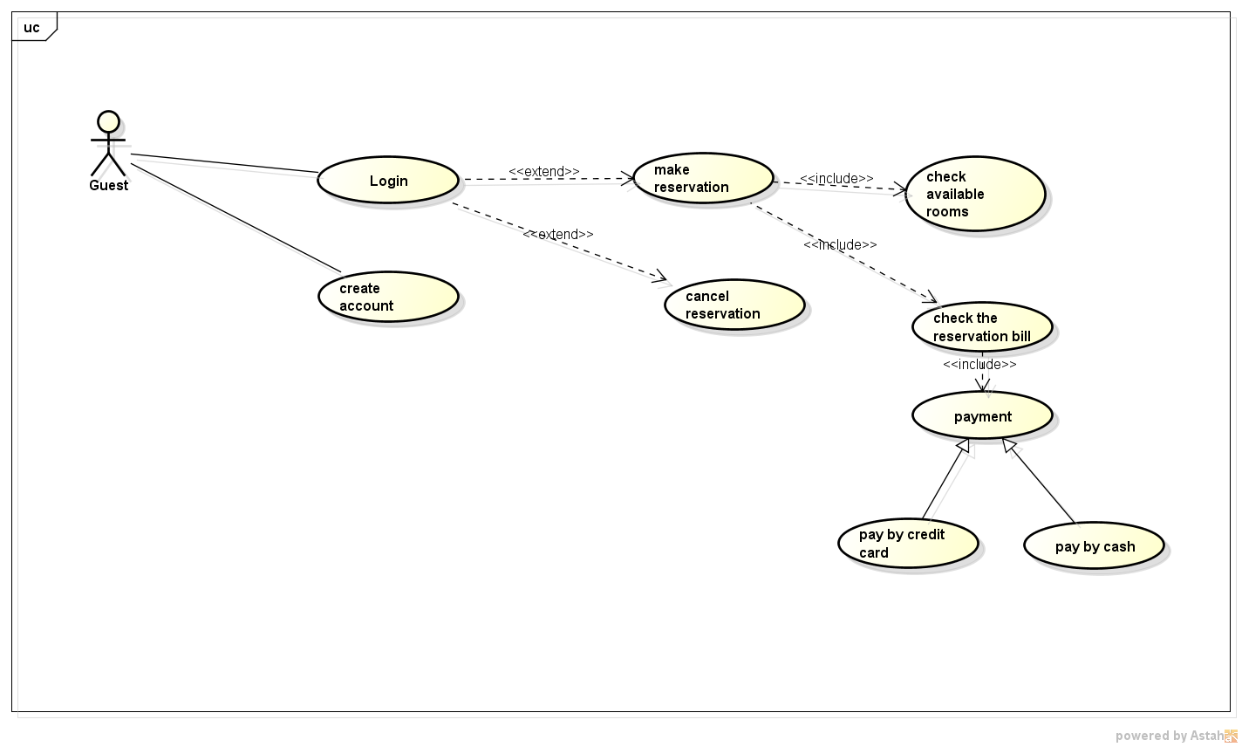

Usecase diagram for reception:

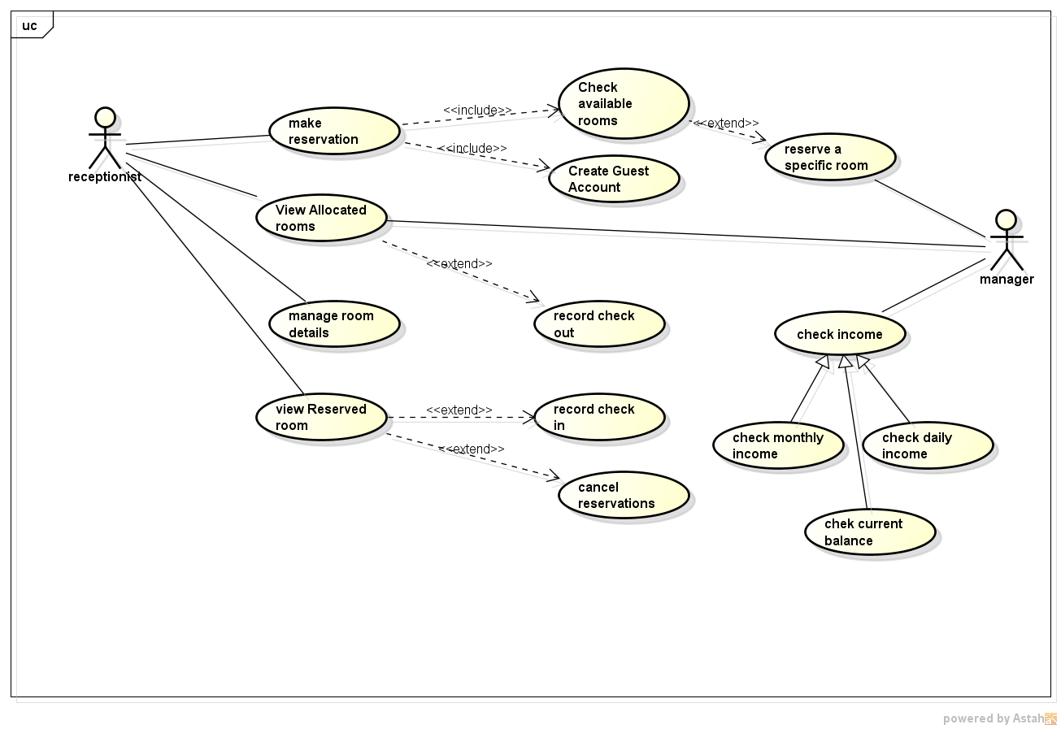

Use case Descriptions

Use Case ID: | UC-01
Use Case Name: | Make Reservation
Actor(s): | Receptionist , Guest
Goal: | Reserve a room for the guest
Related Use cases | Includes (UC-02 , UC-03)
Pre-Condition: | None(there are no prior conditions to use this use case)
Basic Flow | User Actions | System Responses
 | - Choose Make reservation option from the menu  - Choose Room Availability  - Choose Guest Account  7.Type Guest ID, Name, Address etc  8.Choose save  10.Choose Reserve | - Display Make reservation screen  - Display Room availability information  6.Display Guest Account information  9. Validate entered information and create a new account  11.Display Room reserved  12.Window Closed
Alternative Flow: | 9)Data format is not valid
Post-Condition: | A room of the desired type will have been reserved

Use Case ID: | UC-02
Use Case Name: | Check Room Availability
Actor(s): | Receptionist , Guest
Goal: | Check a desired room Availability for the guest
Related Use cases | Included in (UC-01) Extended by (UC-04)
Pre-Condition: | Availability of a room is to be confirmed to reserve for the guest
Basic Flow | User Actions | System Responses
 | 1.Choose Room availability  3. Choose Desire Room  5.Choose Reserve  7.Choose Save | 2. Message Displayed Room availability information  4.Message displayed room type, number of beds etc and availability  6. Message displayed Reserved  8.Window closed
Alternative Flow: | None
Post-Condition: | Available room is to be checked and reserved for the guest

Use Case ID: | UC-03
Use Case Name: | Create Guest Account
Actor(s): | Receptionist
Goal: | To add the guest information (Name , CNIC # , Address etc)
Related Use cases | Included in (UC-01)
Pre-Condition: | Get the required data about the customer
Basic Flow | User Actions | System Responses
 | 1.Choose Create Guest Account  3.Choose Add Guest  5.Type Name , Address etc  6.Choose Save  8.Choose Ok | 2. Message Displayed New Guest  4.Message displayed Enter Name , Address ,Contact number etc  7.Window displayed Guest ID  9.Window closed
Alternative Flow: | Data Format is not valid
Post-Condition: | The information about the guest is to be saved

Use Case ID: | UC-04
Use Case Name: | Reserve a specific room
Actor(s): | Manage
Goal: | To reserve a specific room for a guest
Related Use cases | Extended in (UC-02)
Pre-Condition: | Room to be reserved should be added
Basic Flow | User Actions | System Responses
 | 1.Choose Reserve a specific room  3.Choose Save | 2. Message Displayed Reserved  4.Window Closes
Alternative Flow: | None
Post-Condition: | The specific room number is assigned to gues

Use Case ID: | UC-05
Use Case Name: | View Allocated Room
Actor(s): | Receptionist , Manager
Goal: | To view the room allocation
Related Use cases | Extended to (UC-06)
Pre-Condition: | View allocated room should have been added
Basic Flow | User Actions | System Responses
 | 1.Choose View Allocated Room  3.Choose desire room  5.Choose ok | 2. Message Displayed Room Allocation information  4.Message displayed information  6.Window closed
Alternative Flow: | None
Post-Condition: | The information about allocation of rooms is viewed

Use Case ID: | UC-06
Use Case Name: | Record Check out
Actor(s): | Receptionist , Manager
Goal: | To check out the record of a guest
Related Use cases | None
Pre-Condition: | Information about record check out should have been added
Basic Flow | User Actions | System Responses
 | 1.Choose Record Check Out  3.Type date  5.Choose ok  8.Choose Ok | 2. Message Displayed record data  4.Message displayed Recorded data  6.Windows closed
Alternative Flow:
Post-Condition: | Record data is checked out

Use Case ID: | UC-07
Use Case Name: | Manage Room Details
Actor(s): | Receptionist
Goal: | To manage the information about room
Related Use cases | None
Pre-Condition: | To manage the room details should have been added
Basic Flow | User Actions | System Responses
 | 1.Choose Manage Room Details  3.Type Room number  5.Choose edit  6.Choose Save  8.Choose Ok | 2. Message Displayed Room Details  4. Message displayed edit room type (A , B , C),Smoking non smoking status etc  9.Message displayed Saved
Alternative Flow: | Data is not valid
Post-Condition: | The Details about managing a room is saved.

Use Case ID: | UC-08
Use Case Name: | View Reserved Room
Actor(s): | Receptionist
Goal: | To View the information about reserved room
Related Use cases | Extended to (UC-09 , UC-10)
Pre-Condition: | To view reserved room details should have been added
Basic Flow | User Actions | System Responses
 | 1.Choose View reserved room  3.Type Room number  5.Choose ok | 2. Message Displayed Reserved Rooms  4.Message displayed Check in date n Check out date  6.Message displayed Saved
Alternative Flow: | Data is not valid
Post-Condition: | The Details about Reserved room is viewed.

Use Case ID: | UC-09
Use Case Name: | Record Check in
Actor(s): | Receptionist
Goal: | To View the information about record check in room
Related Use cases | Extended by UC-08
Pre-Condition: | To View record check in details should have been added
Basic Flow | User Actions | System Responses
 | 1.Choose Record Check in  3.Type Room number  5.Choose ok | 2. Message Displayed  4.Message displayed Check in date
Alternative Flow: | Data is not valid
Post-Condition: | The Details about Record check in room is viewed.

Use Case ID: | UC-10
Use Case Name: | Cancel Reservation
Actor(s): | Receptionist , Guest
Goal: | To Cancel the reservation of a room
Related Use cases | Extended by (UC-08)
Pre-Condition: | To cancel the reservation should have been added
Basic Flow | User Actions | System Responses
 | 1.Choose Cancel reservation  3.Type Room number , Guest ID  5.Choose save  6.Choose Exit | 2. Message Displayed Room number , guest ID  4.Message displayed reserved canceled  7.Window closes
Alternative Flow: | Data is not valid
Post-Condition: | Reservation of a room is canceled.

Use Case ID: | UC-11
Use Case Name: | Check income
Actor(s): | Manager
Goal: | To View the income of a hotel
Related Use cases | Generalized by (UC-12 , UC-13 , UC-14)
Pre-Condition: | To view income should have been added
Basic Flow | User Actions | System Responses
 | 1.Choose Check income  3.Type Desired income  5.Choose Exit | 2. Message Displayed Check monthly , daily , current  4.Message displayed about the desired income  6.Window closes
Alternative Flow: | None
Post-Condition: | The Details about income is checked

Use Case ID: | UC-12
Use Case Name: | Check monthly
Actor(s): | Manager
Goal: | To check income on monthly basis
Related Use cases | Generalization (UC-11)
Pre-Condition: | To check monthly income should have been added
Basic Flow | User Actions | System Responses
 | 1.Choose Check monthly  3.Choose Ok  4.Choose Exit | 2. Message Displayed income on monthly basis  5.Window closes
Alternative Flow: | None
Post-Condition: | Income on monthly basis is checked.

Use Case ID: | UC-13
Use Case Name: | Check Daily
Actor(s): | Manager
Goal: | To check daily income of a hotel
Related Use cases | Generalization (UC-11)
Pre-Condition: | To check daily income should have been added
Basic Flow | User Actions | System Responses
 | 1.Choose Cancel Daily  3.Choose Ok  4.Choose Exit | 2. Message Displayed Daily income  5.Window closes
Alternative Flow: | None
Post-Condition: | Income on daily basis is checked.

Use Case ID: | UC-14
Use Case Name: | Check current balance
Actor(s): | Manager
Goal: | To check current balance of a hotel.
Related Use cases | Generalization (UC-11)
Pre-Condition: | To check current balance should have been added
Basic Flow | User Actions | System Responses
 | 1.Choose Check current balance  3.Choose Ok  4.Choose Exit | 2. Message Displayed Current balance  5.Window closes
Alternative Flow: | None
Post-Condition: | Current balance of a hotel is checked.

Use Case ID: | UC-15
Use Case Name: | Login
Actor(s): | Guest
Goal: | To login the guest.
Related Use cases | Extended to (UC-01 , UC-10)
Pre-Condition: | To login by the guest should have been added
Basic Flow | User Actions | System Responses
 | 1.Choose Login  3.Type Guest ID  5.Choose Ok | 2. Message Displayed Guest ID  4.Messgae displayed  6.Window closes
Alternative Flow: | Data is not valid
Post-Condition: | Guest is logged in.

Use Case ID: | UC-16
Use Case Name: | Check the reservation bill
Actor(s): | Guest
Goal: | To check reservation bill amount by a guest of a hotel.
Related Use cases | Included by (UC-01)
Pre-Condition: | To check the reservation bill should have been added
Basic Flow | User Actions | System Responses
 | 1.Choose Check the reservation bill  3.Choose Ok  4.Choose Exit | 2. Message Displayed Total bill  5.Window closes
Alternative Flow: | None
Post-Condition: | Reservation bill of a guest room is checked.

Use Case ID: | UC-17
Use Case Name: | Payment
Actor(s): | Guest
Goal: | To pay the reservation bill of a room.
Related Use cases | Generalized by (UC-18 , UC-19)
Pre-Condition: | To pay the reservation bill should have been added
Basic Flow | User Actions | System Responses
 | 1.Choose Payment  3.Type pay by credit card or by cash  4.Choose Ok | 2. Message Displayed Pay by credit card or Pay by cash  4.Message displayed Total amount  5.Message displayed Bill paid
Alternative Flow: | Data is not valid
Post-Condition: | The reservation bill is paid.

Use Case ID: | UC-18
Use Case Name: | Pay by credit card
Actor(s): | Guest
Goal: | To pay reservation bill by credit card.
Related Use cases | Generalization (UC-17)
Pre-Condition: | To pay the bill by credit card should have been added.
Basic Flow | User Actions | System Responses
 | 1.Choose Pay by credit card  3.Type card number  5.Chosose Ok | 2. Message Displayed Enter card number  4a).Message displayed verified  4b).Message displayed error  6.Window closes
Alternative Flow: | Data is not valid
Post-Condition: | Reservation bill is paid by credit card.

Use Case ID: | UC-19
Use Case Name: | Pay by cash
Actor(s): | Guest
Goal: | To pay reservation bill by cash.
Related Use cases | Generalization (UC-17)
Pre-Condition: | To pay reservation bill by cash should have been added
Basic Flow | User Actions | System Responses
 | 1.Choose Pay by cash  3.Choose Ok  5.Choose Exit | 2. Message Displayed Total amount  4.Message displayed Paid  6.Window closes
Alternative Flow: | None
Post-Condition: | Reservation bill is paid by cash.

Noun Identification
Nouns:
- Guest
- Receptionist
- Guest
- Guest
- Reservation
- Receptionist
- No. of rooms
- No. of beds
- Room
- Rooms
- Available rooms
- Class
- Room
- Hotel
- Classes of room
- Daily rate
- Room
- Number
- Type of beds
- Room number
- Smoking/non-smoking status
- Guest
- Rooms
- Dates
- Reservation
- Guest details
- Name
- Phone number
- Address
- NIC Number
- Credit card details
- Guest Information
- Receptionist
- Assign
- Customer id
- Check In
- Room
- Allocated
- Check out
- Bill
- Receptionist
- Customer
- Baggage
- Employee
- Room
- Baggage
- Check out
- Customer
- Orders
- Food item
- Tea
- Delivered
- Staff
- Reservation
- Canceled
- Time
- Fee
- Cancelation
- Check out
- Clerk
- Amount
- Bill
- Report
- Guest
- Pay
- Cash
- Credit card
- amount
- clerk
- receipt
- bill
- Automated system
- Guest
- Account
- Details
- Available rooms
- Reservation
- Guest details
- Phone Number
- Address
- Name
- Room details
- Available room
- Dates
- Reservation
- Room
- Reservation charges
- Paying machine
- Confirmation
- Non-refundable
- Reservation
- Cancelled
- Time
- Check In
- Customer
- Bill
- Reservation
- Clerk
- Night
- Staying charges
- Reservation charges
- Paid
- Reservation
- canceled

Eleminated Nouns and Identified Classes
- Reservation
- Room
- Guest Information
- Check In
- Check out
- Bill
- Cancelation
- Guest Account

Class diagram:
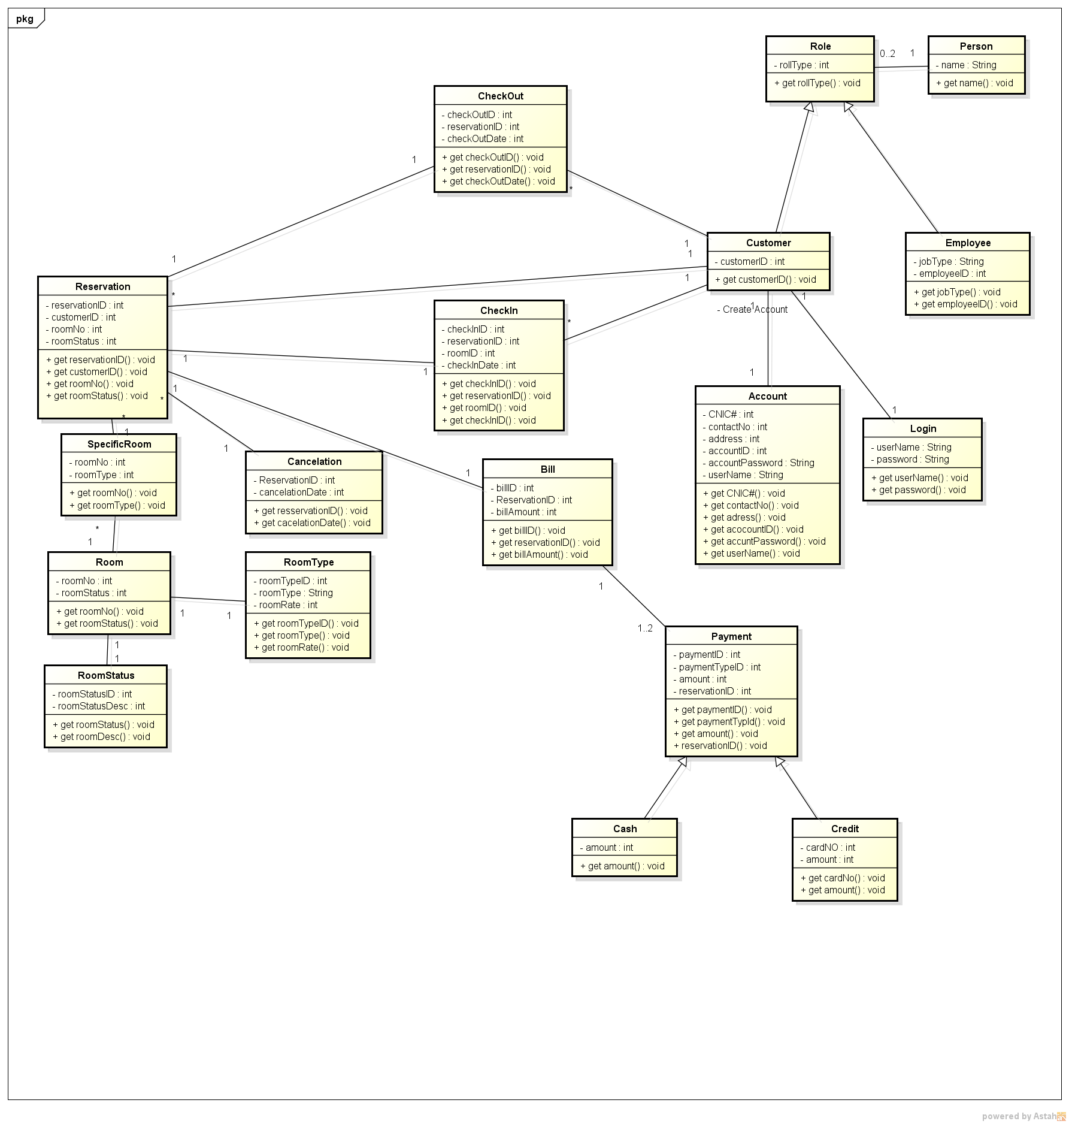

Sequence diagrams :
Make Reservation: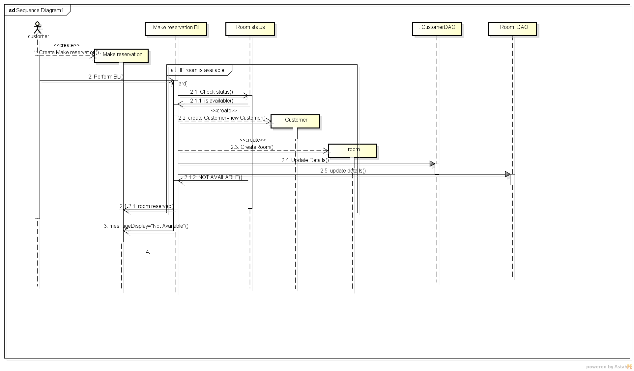

Cancellation:
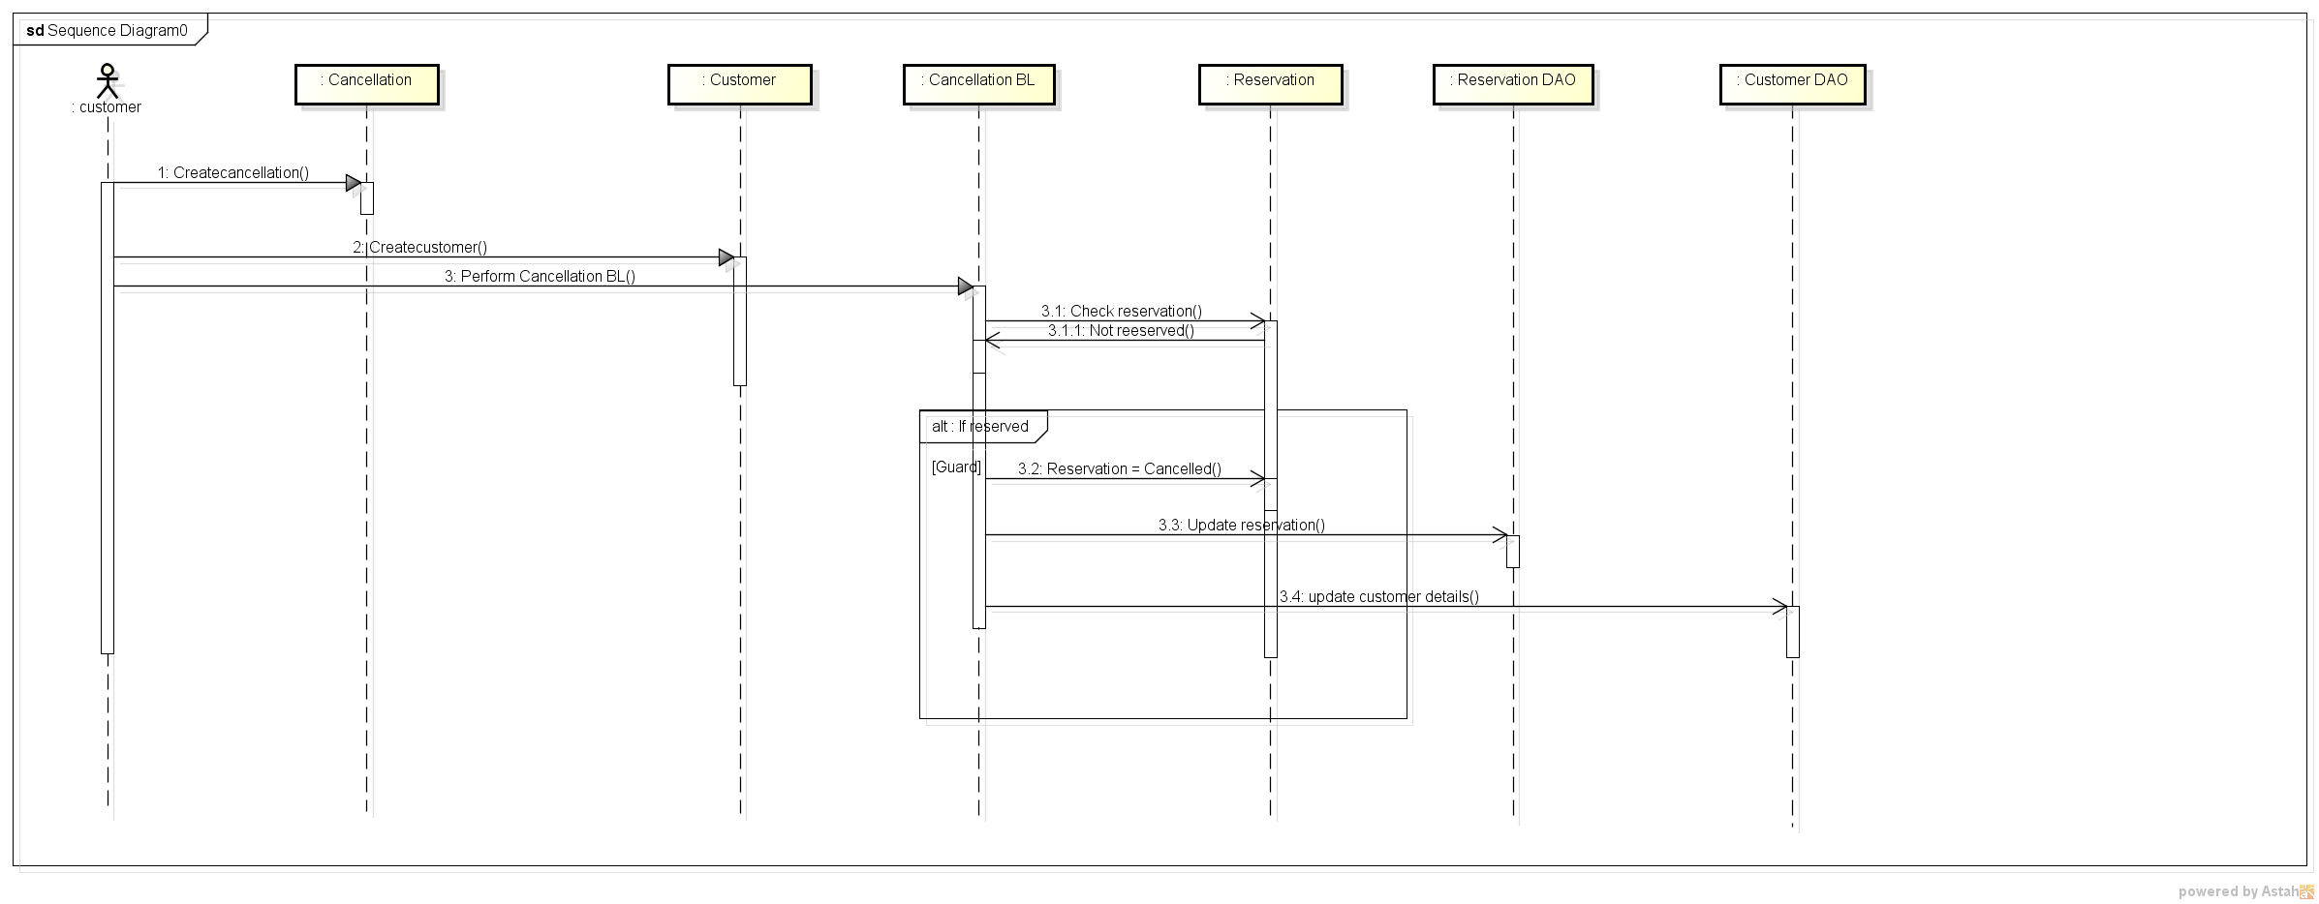

Create Guest Account:
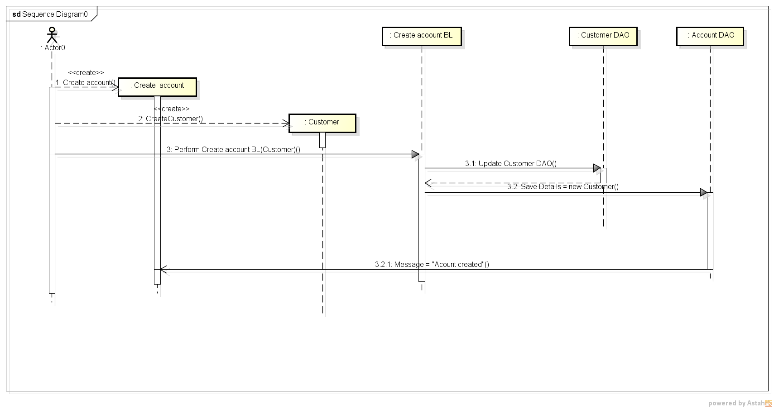

Component diagram:
For Cancellation:
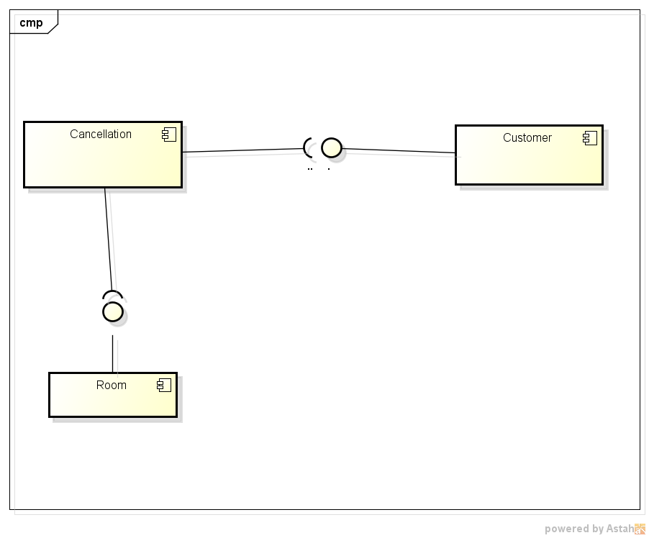

For Making reservation:
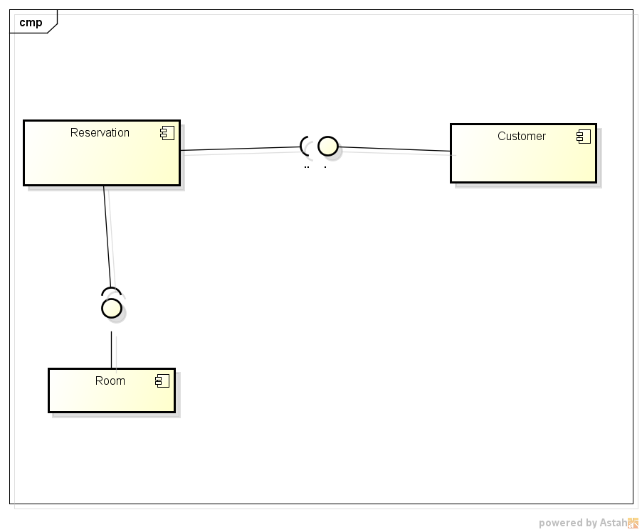

Deployment Diagrams:
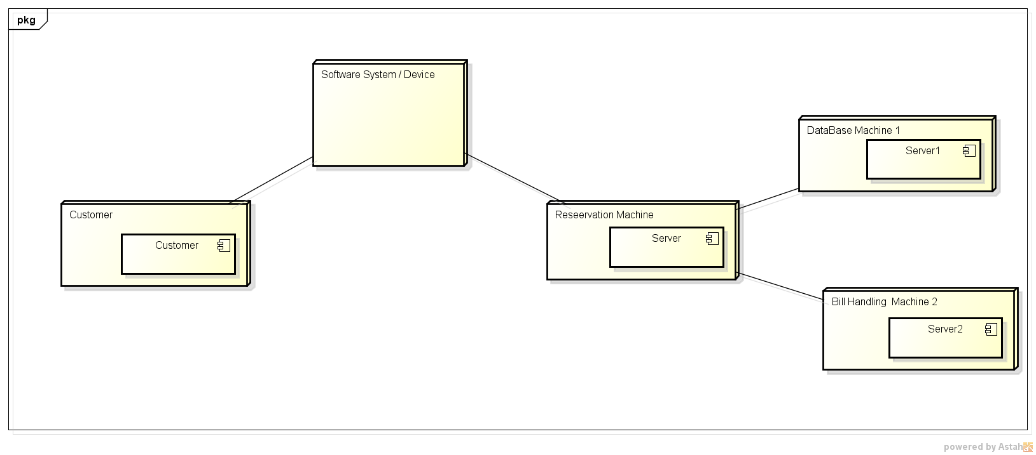

Architectural Patterns:
For Reception: For reception , Transaction pattern is applied as it is a process reads a series of inputs one by one.
  - Each input describes a transaction – a command that typically some change to the data stored by the system
  - There is a transaction dispatcher component that decides what to do with each transaction
  - This dispatches a procedure call or message to one of a series of component that will handle the transaction
In our system the user as a transaction goes to transaction dispatcher and ask it the desired option which may exist between room reservation , room cancellation ,check bill amount or bill payment etc
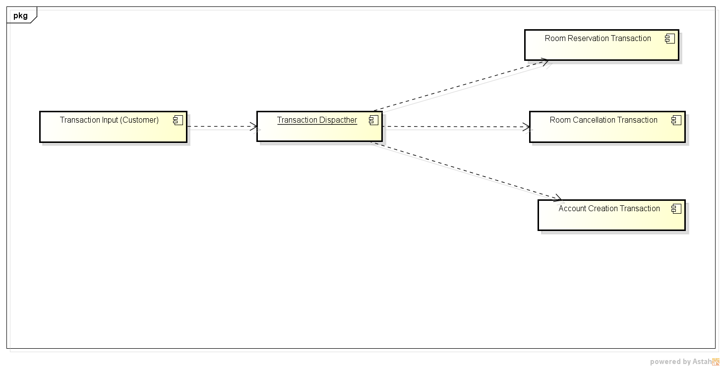

For Automated System:
An architectural pattern used to help separate the user interface layer from other parts of the system
  - The model contains the underlying classes whose instances are to be viewed and manipulated
  - The view contains objects used to render the appearance of the data from the model in the user interface
  - The controller contains the objects that control and handle the user’s interaction with the view and the model
In our system the user can view our application source and select the desired option which will be received by the control and it ask the model to complete the desire.Desire may be to reserve a room , cancel room etc
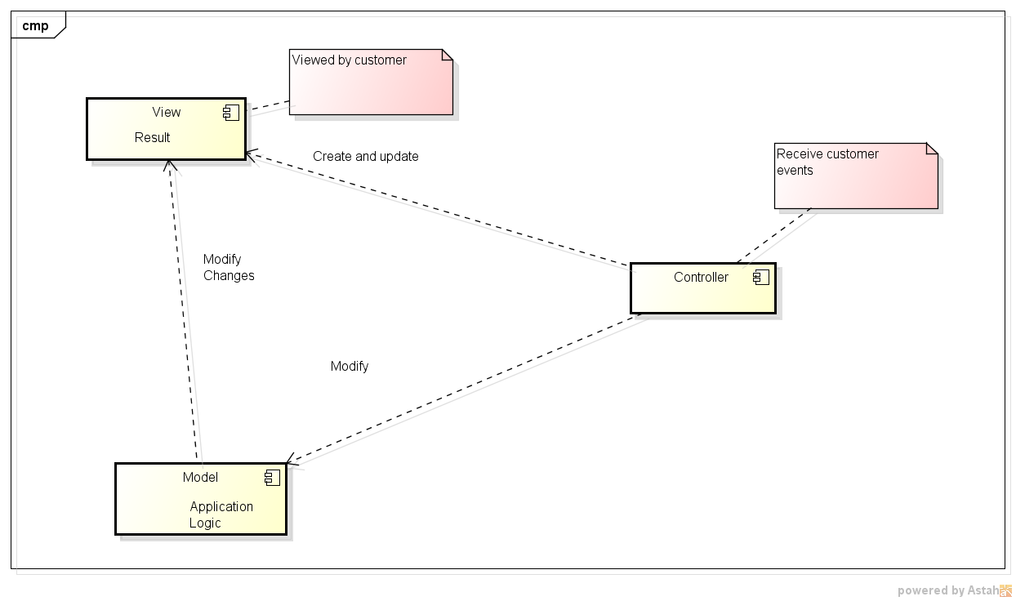

Multilayer Architecture Pattern:
In a layered system, each layer communicates only with the layer immediately below it. In our system we have shown Business Layer and DataAccess layer from which the user can easily choose its desire field , for the hotel management business layer is formed while for the guest dataaccess part is shown from here a guest can make reservation and cancel reservation.
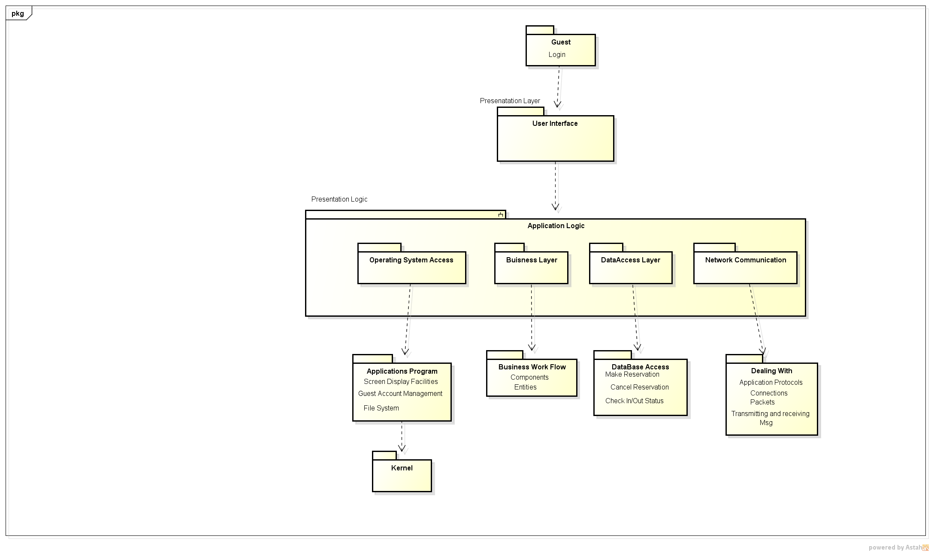

Database Design: